

**Project Report**

* + **Project Name:**   
    US Airline Twitter Sentiment Analysis
  + **Team Members:**  
    - Youssef Badreldin   
    “20100294”  
      
    - Shaden Hazem   
    “20100253”

1. Importing required libraries and reading excel file using read_csv.

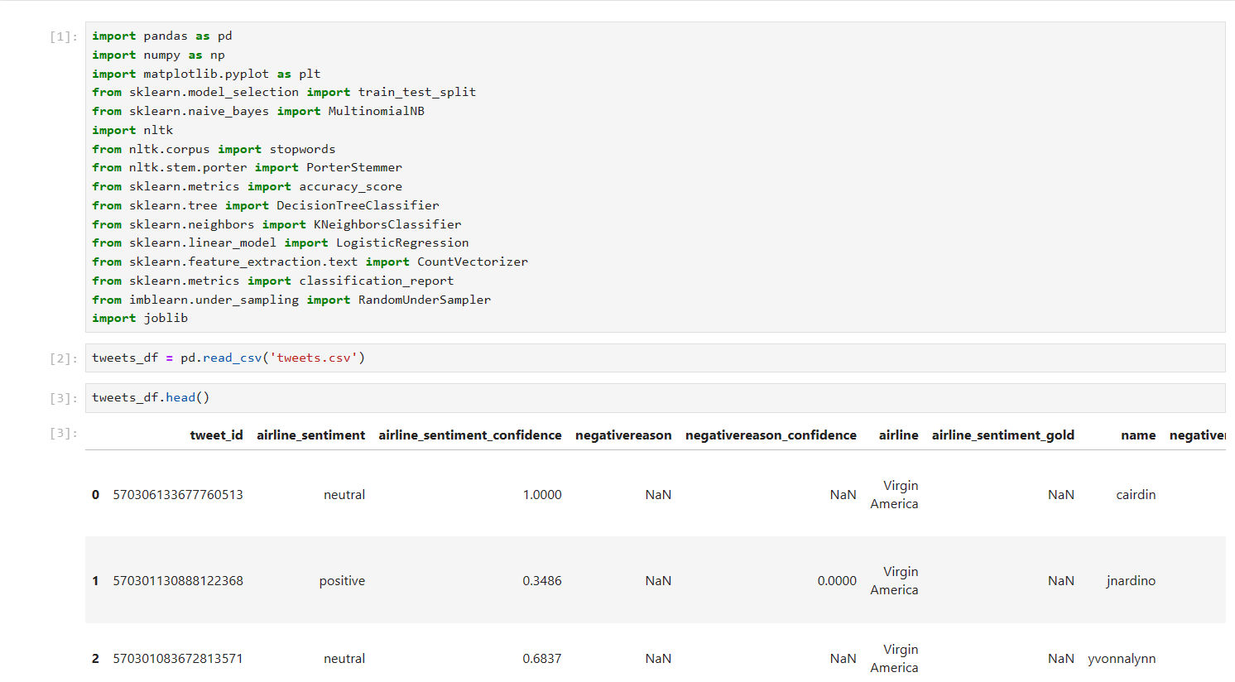

2.graph plots used to highlight the Sentiments.

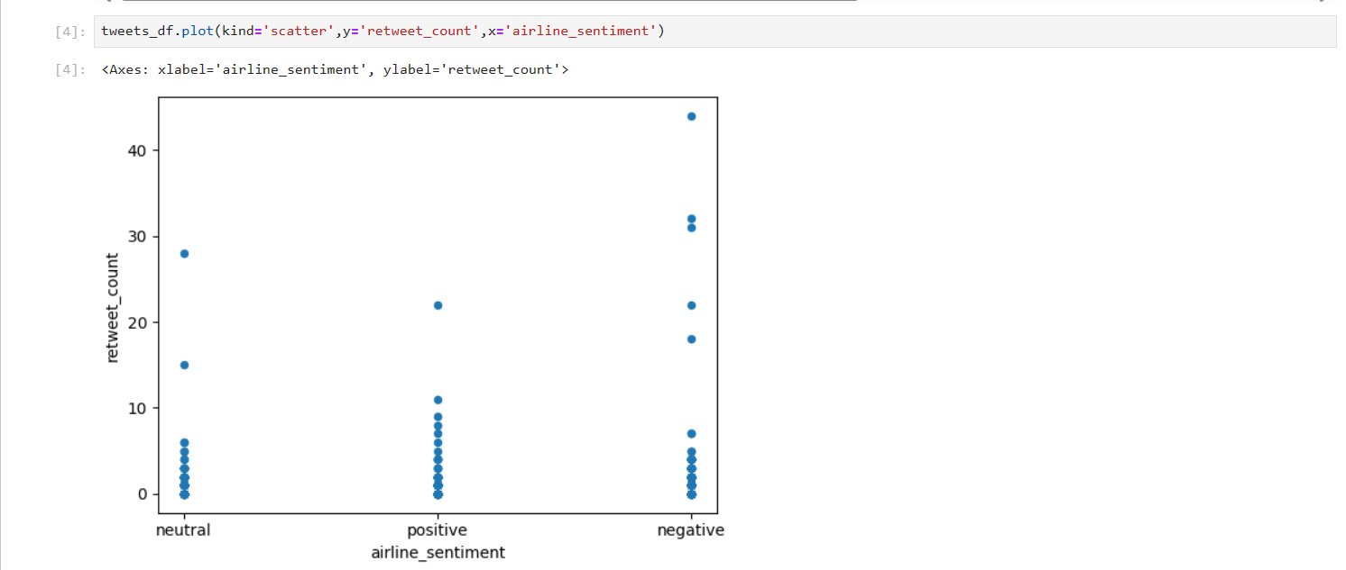

3. Showing Nulls in every row and dropping all of the nulls and unnecessary columns.

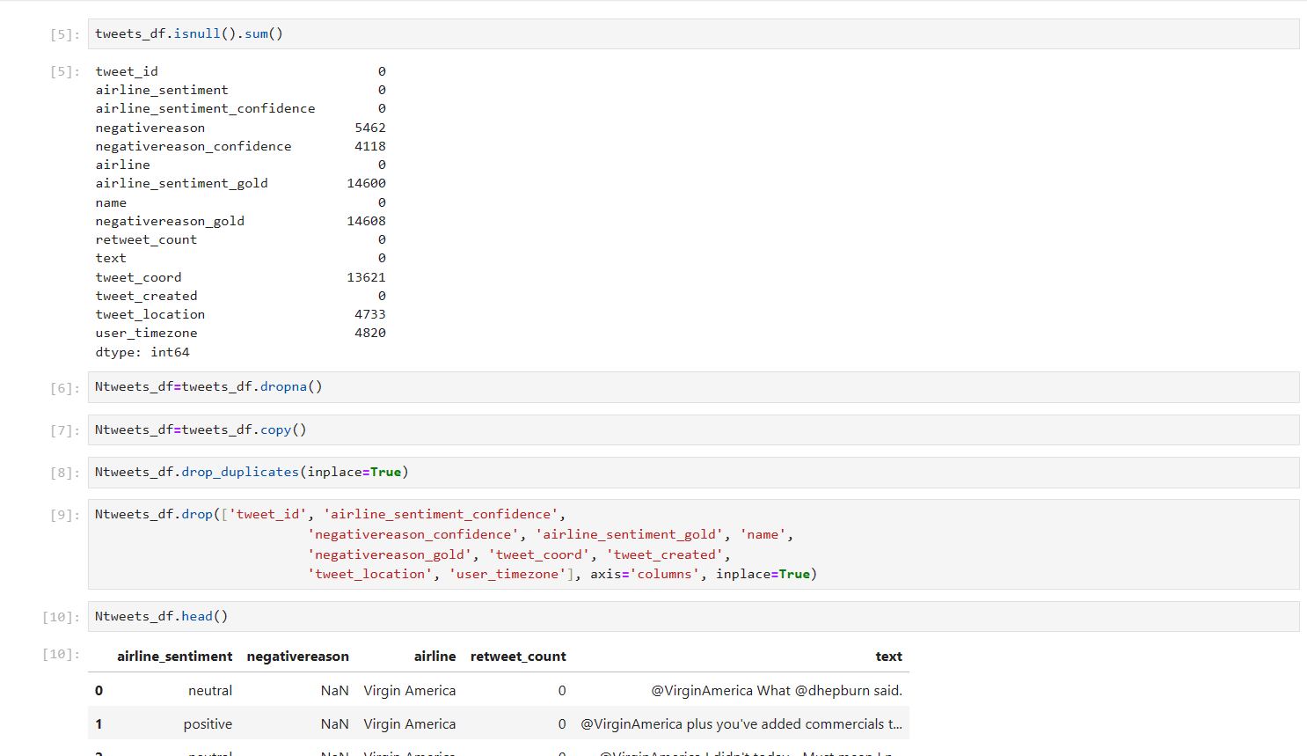

4. Stop words in NLP and text mining applications, to eliminate unimportant words, allowing applications to focus on the important words instead.

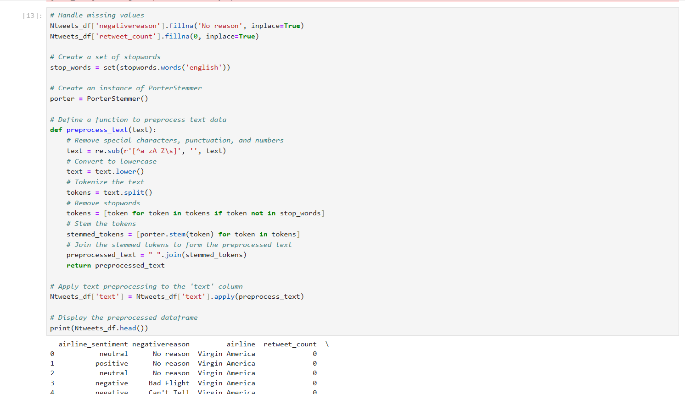

5.Training the model:

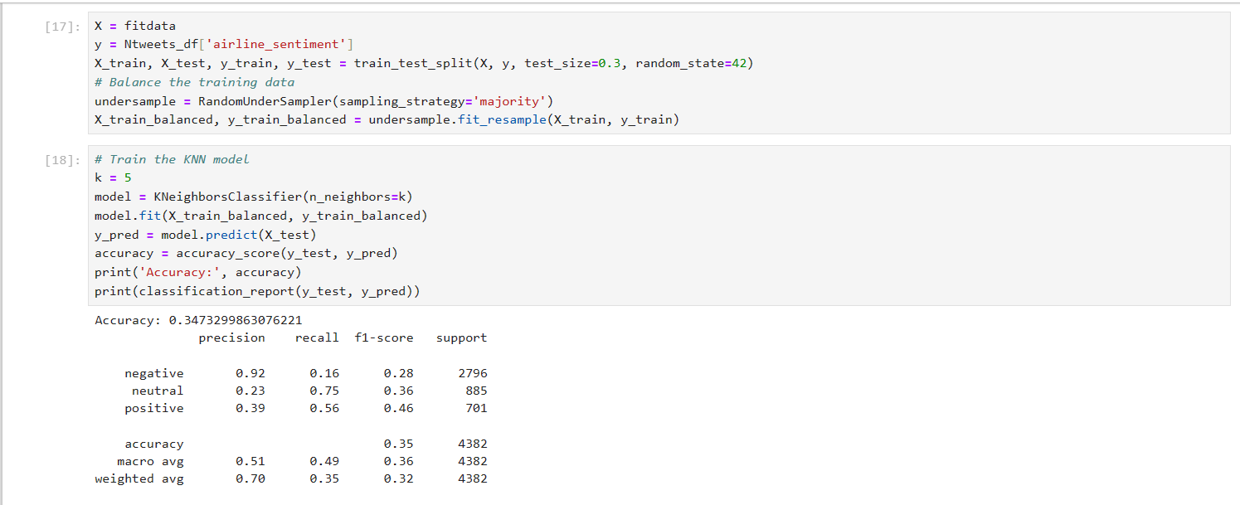

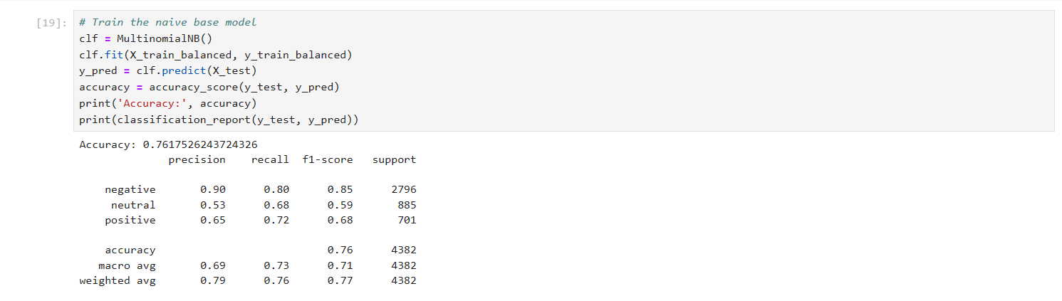

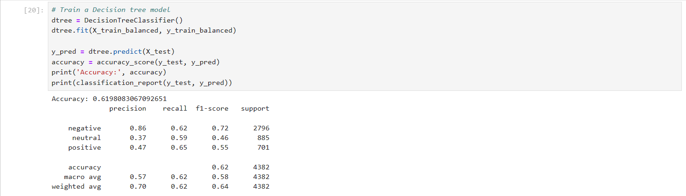

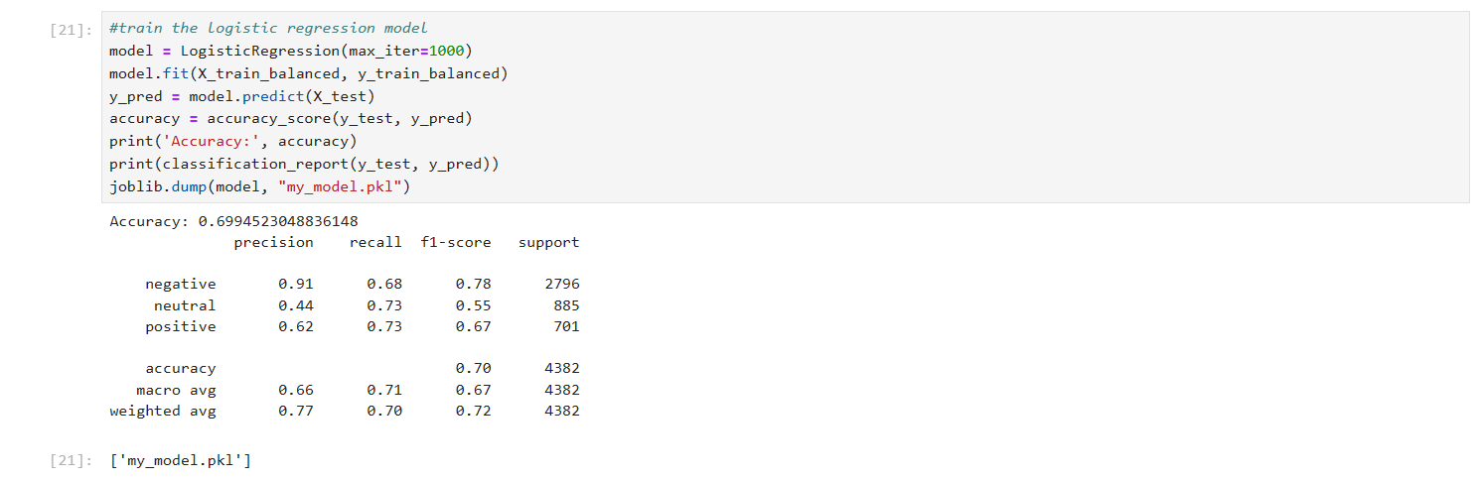

We tried the 4 models (Logistic Regression, Naïve Base, Decision Tree, KNN) and the best fit for our model is Naïve Base.

**GUI**

1. Importing required libraries

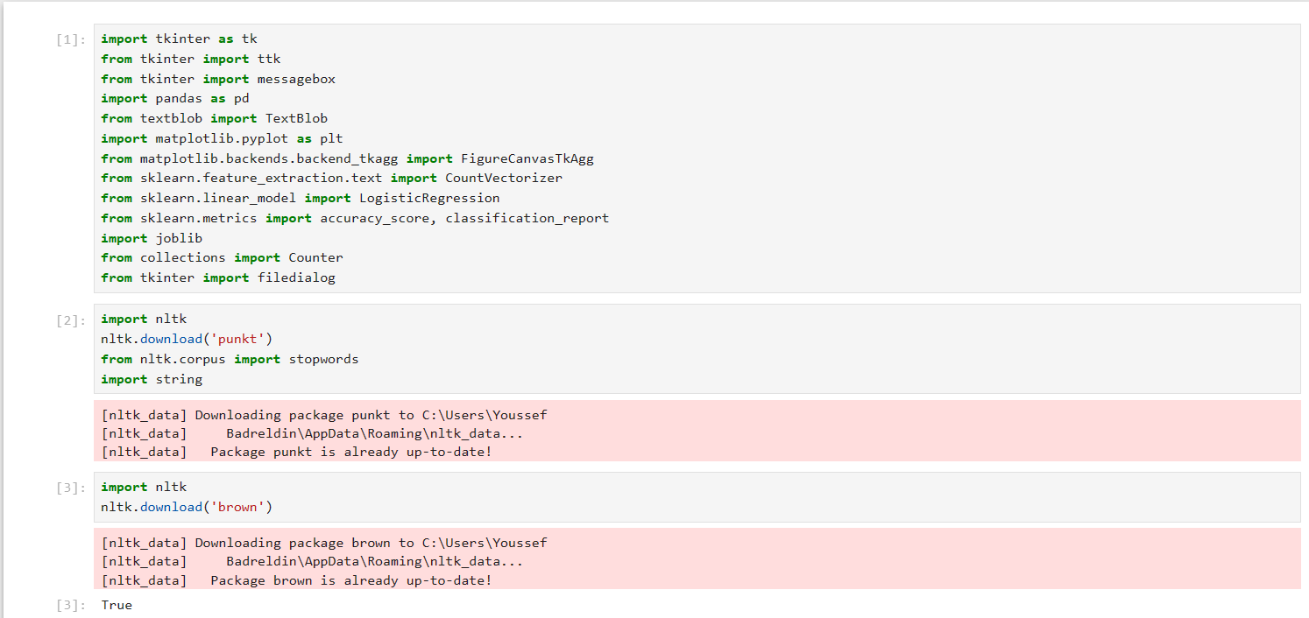

1. Analyze sentiment for each company  
   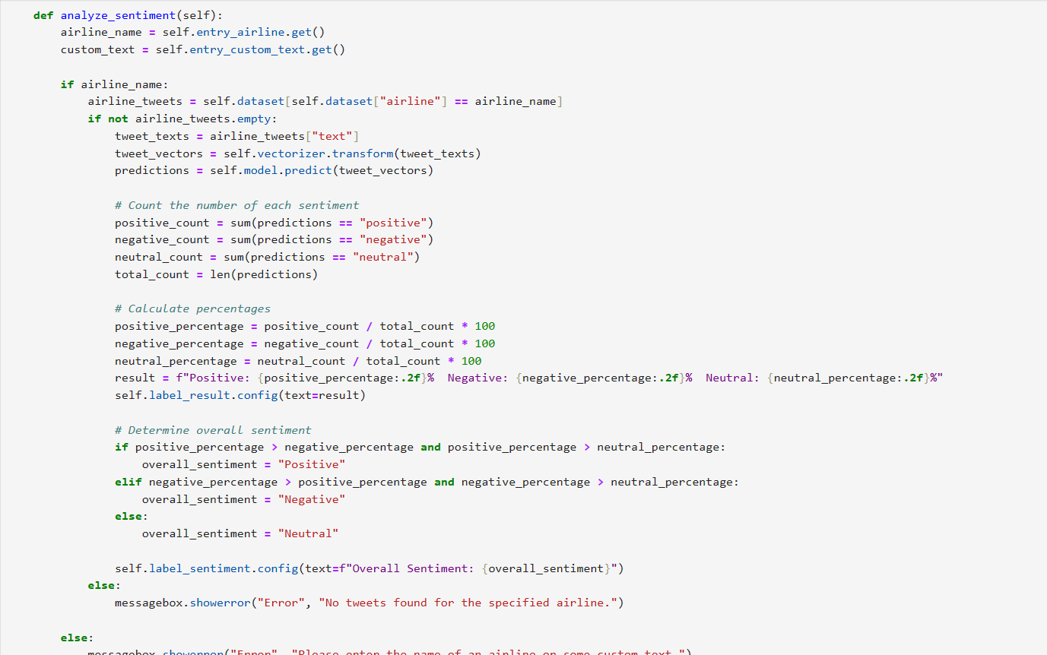

3.Analyze Text Sentiment  
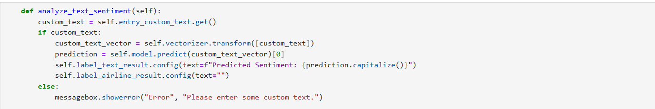

4. Visualization for sentiment

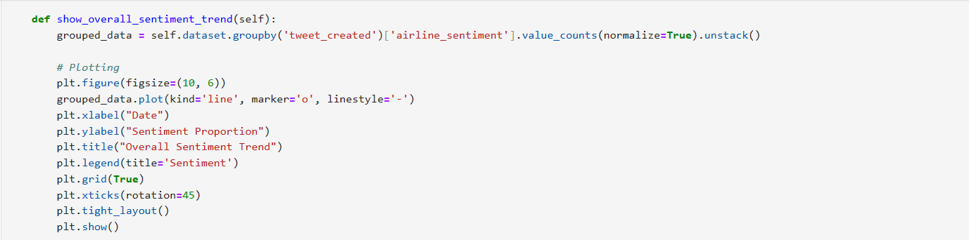

5. Show top Keywords  
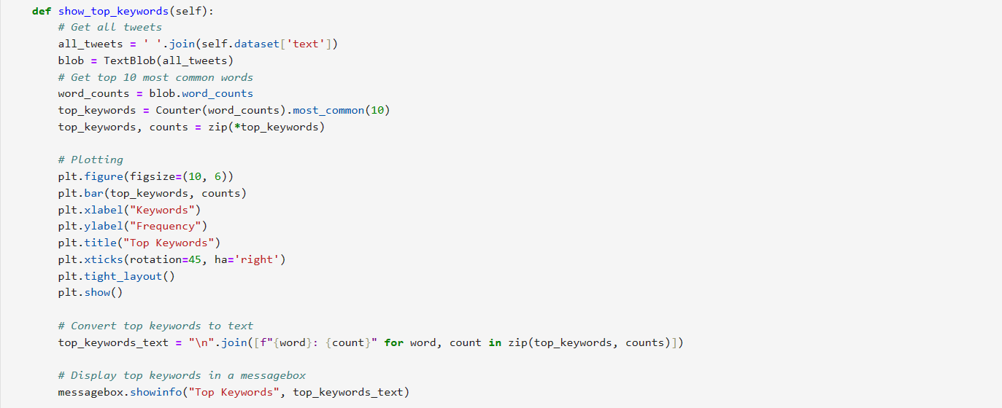

6. Show comparison between all companies  
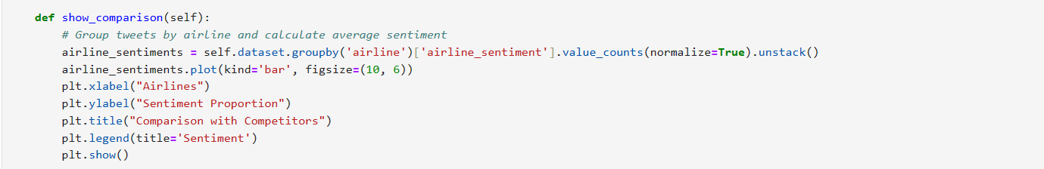

7. Show distribution of whole sentiment of whole file  
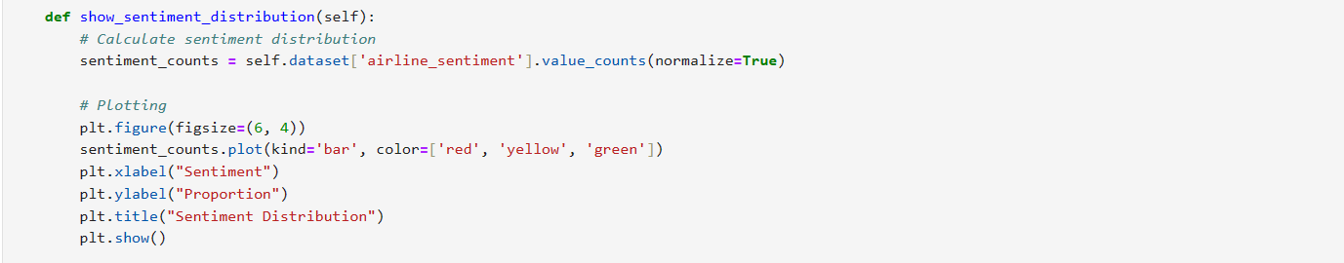

8. Save results in file  
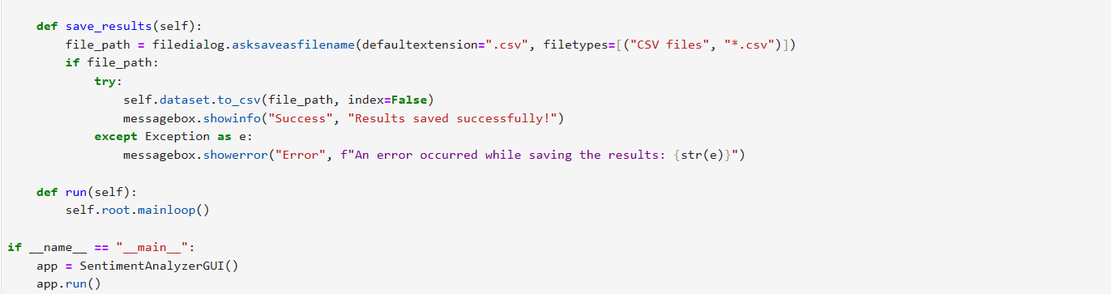

9. Convert ipynb file to py  
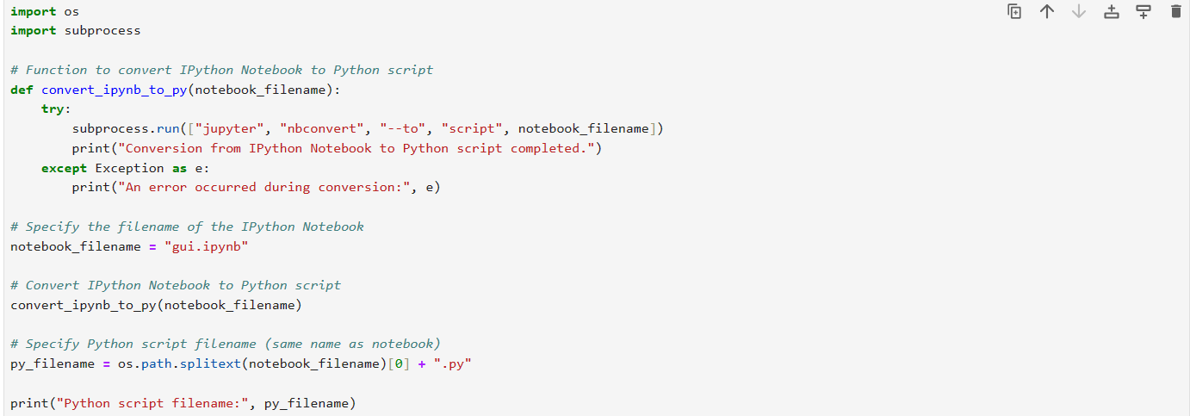

10. Convert py file to exe

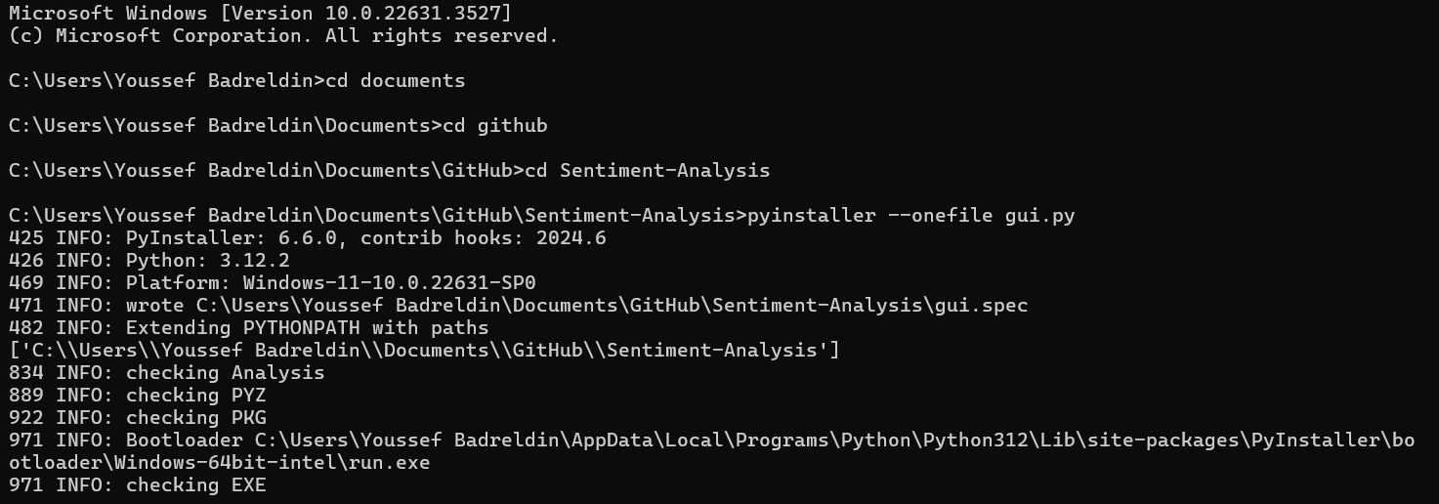

**Interface**

1. analyzed sentiment 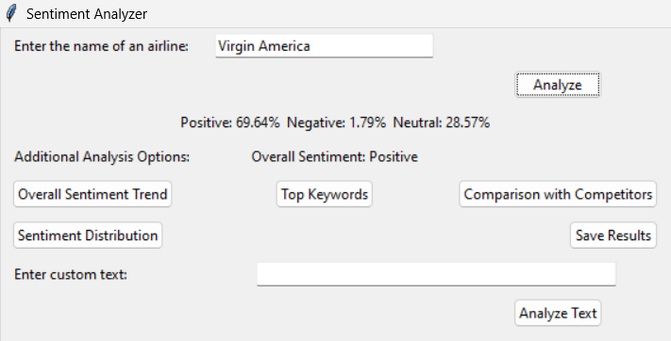

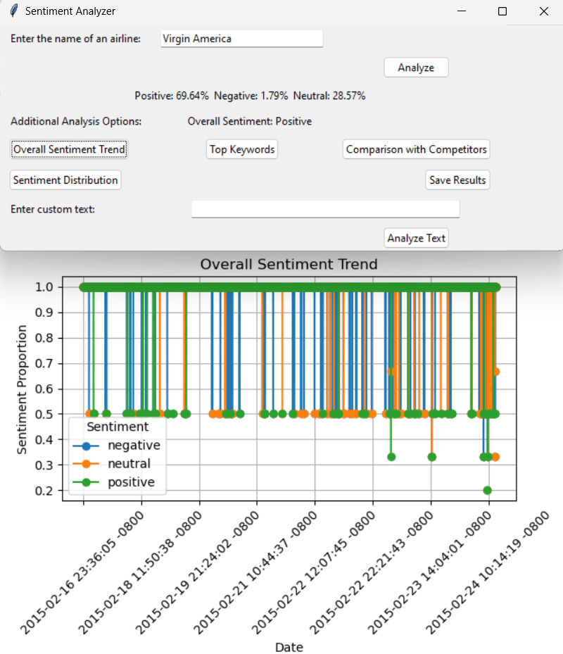2.Overall Sentiment Trend

3.Top Keywords  
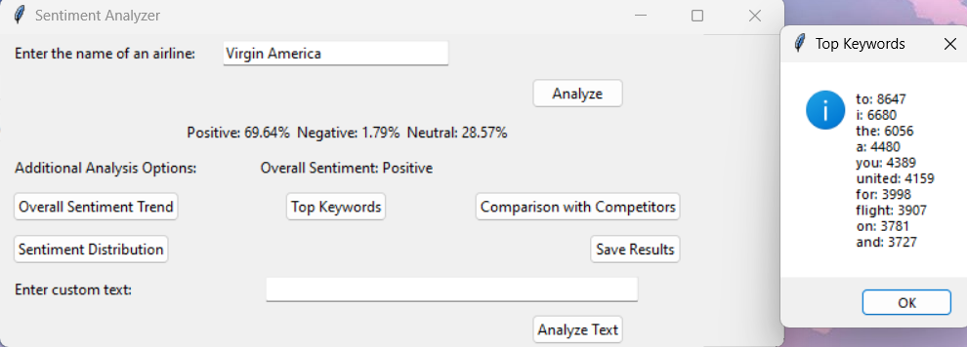

4.Sentiment Distribution  
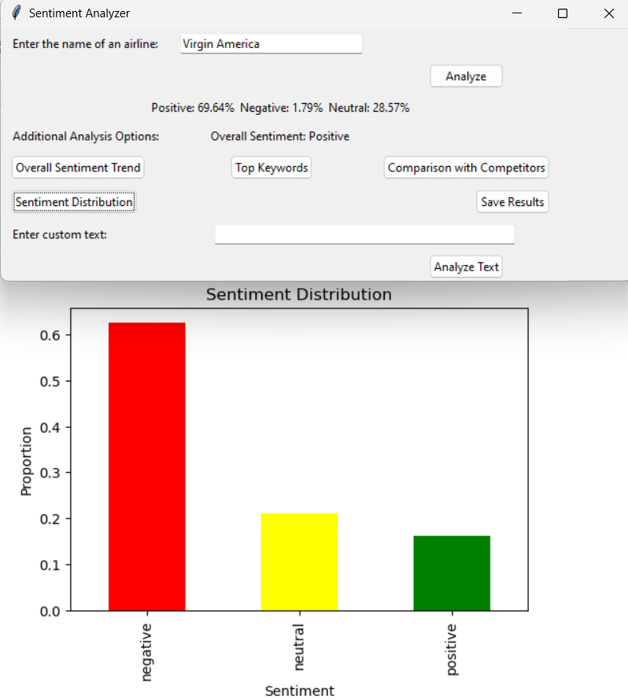

5.Comparision with competitors  
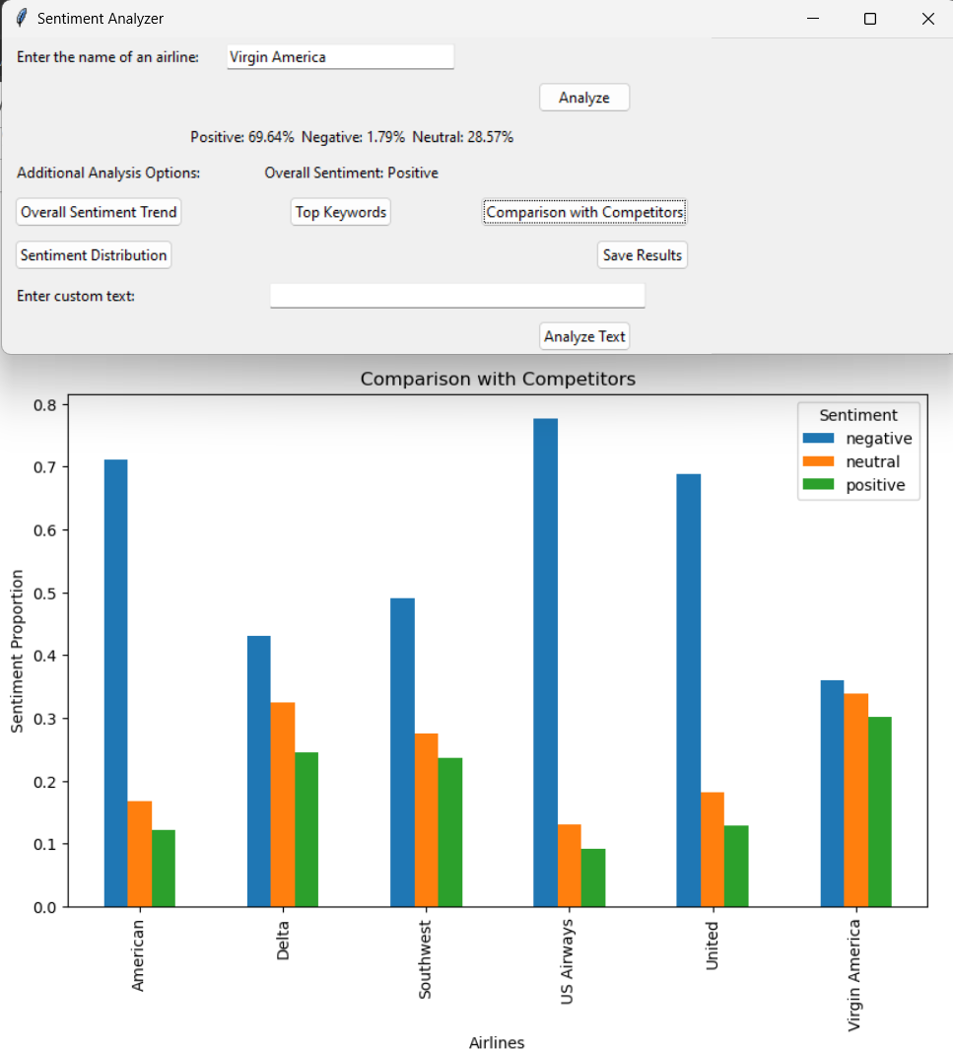

6. Text Analyze



